ES - Sprint 1 – Design Pattern (GOF) 1

**Singleton**

Describes a way to create an object. A class has only one instance (or limited few) and provide a global point to access it.

This pattern permits a “Lazy creation”, that means that the object is not created until is truly needed. As the object is not created until the getInstance() method is called, our program is more efficient. Especially, if the object is large than this pattern might be helpful.

* 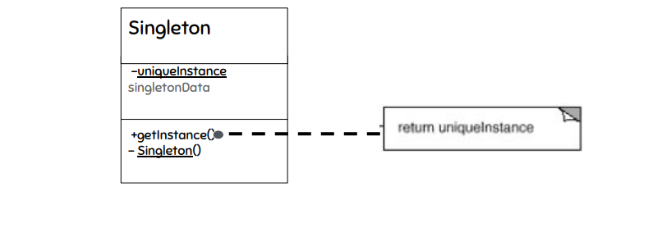**Structure**
* 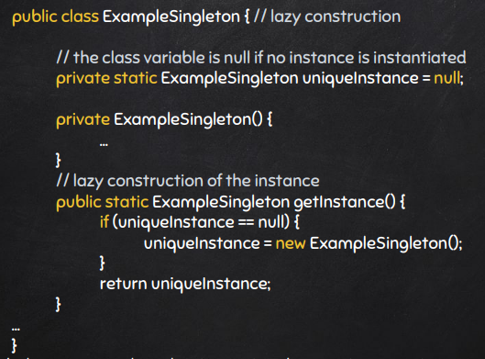**Singleton java example (Code Snippet)**

**Code location:**

The class is in the following path:

“*src\main\java\org\jabref\gui\extrenalfiletype\ExternalFileTypes.java*”

* **Instance**



* **Constructor**



* 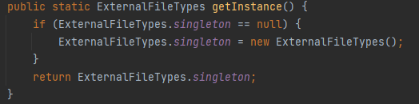**getInstance() method**

**Justification:**

As shown above the class (ExternakFileTypes) has only one instance (“*singleton*”) and must be static.

The constructor of class is private and the method getInstance() that instantiates the class “if” is not already instantiated. This provides global access to a class that is restricted to one instance.